EXERCISE-21

21.Design DFA using simulator to accept even number of a’s.

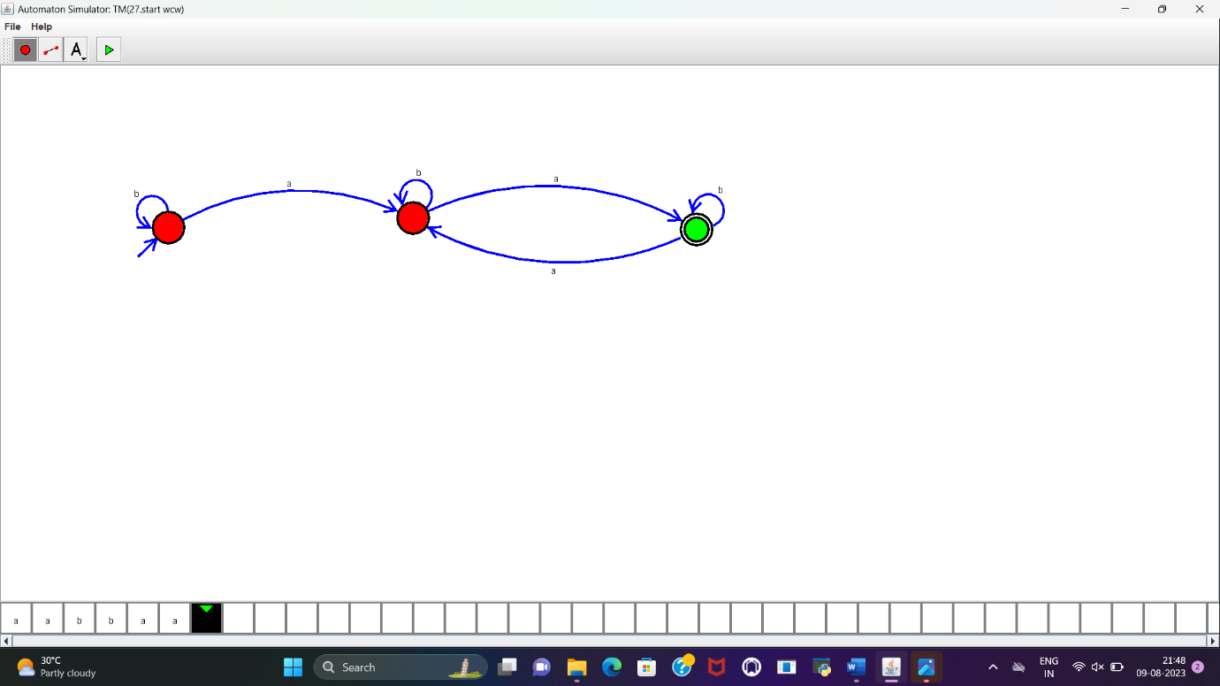

RESULT:

DFA to accept the even number of a’s is designed and implemented successfully.